ARGYLL AND BUTE COUNCIL
Education Services

Islay High School
Handbook
Academic Year 2022/2023

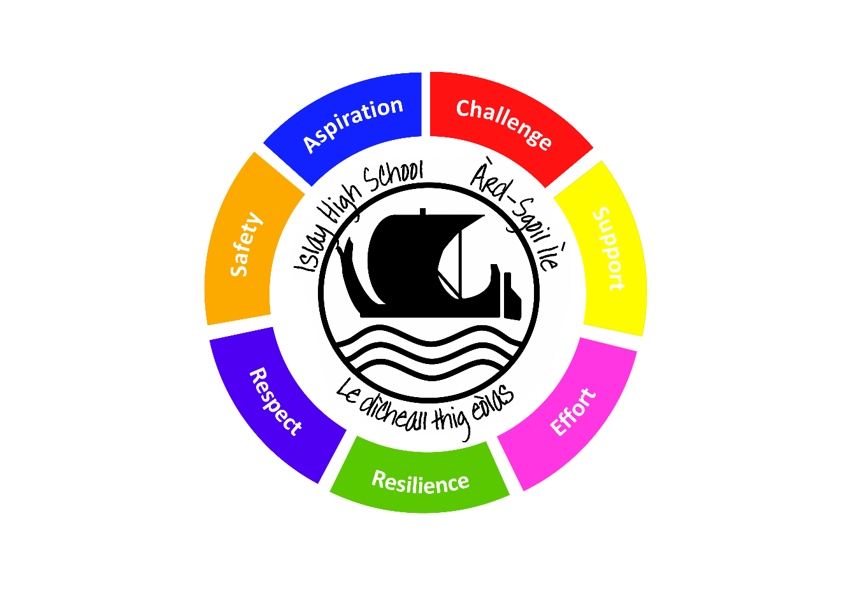



This document is available in alternative formats, on request (please contact the Head teacher).
CONTENTS

GENERAL SCHOOL INFORMATION 4
Contact Details 4
School Roll and Stages 4
School Staff 5
School Day 6
Early Learning and Childcare Provision 6
Visits of Prospective Parents/Carers 7
School Uniform 7
School Clothing Grants 8
Parental Concerns 8
Pupil Absence Procedures 9
Parent / Carer Contact Details 10
The Complaints Procedure 10
PARENTAL INVOLVEMENT 11
Homework 11
Becoming Involved in School 11
Opportunities for Parental Involvement 11
Parent Councils 12
Parentzone Scotland 13
Read, Write, Count 13
First Minister’s Reading Challenge 13
SCHOOL ETHOS 13
School and Community Links 15
Promoting Positive Behaviour 16
Discipline 16
Anti-Bullying 17
Celebrating Achievement 17
Wider-Curricular Activities 17
Pupil Council 17
CURRICULUM FOR EXCELLENCE (CfE) 18
Learning Opportunities 18
Curriculum Levels 19
The Senior Phase 19
Skills for Learning, Life and Work 19
16+ Learning Choices 20
The Pupils’ and Parents’ Voice 20
The Curriculum at School, Local and National Level 20
Careers Information Advice and Guidance 20
Financial Guidance 21
Sexual Health and Relationships Education 21
Drugs Education 21
Religious and Moral Education 22
ASSESSMENT 23
The Scottish National Standardised Assessments (SNSA) 23
REPORTING 25
TRANSITIONS 26
Transfer to Secondary School 26
Moving from Stage to Stage 26
Moving Between Schools 26
Liaison with Local Schools 26
Leaving School 27
SUPPORT FOR PUPILS 28
Support Arrangements for All Pupils 28
Identifying and Addressing Additional Support Needs 28
Staged Intervention 29
Further Information about Additional Support Needs (ASN) 30
SCHOOL IMPROVEMENT 33
Main Achievements 33
Improving Standards 33
School Performance 35
Attendance and Exclusion 37
For the third year running, we have avoided any need for exclusions. 38
SCHOOL POLICIES AND PRACTICAL INFORMATION 39
Early Learning and Childcare Meals 39
Scottish Milk and Healthy Snack Scheme (SMHSS) 39
School Meals 39
Packed Lunches 40
Free School Meals 41
Special Dietary Requirements 41
Health Care 42
Administration of Medicines 42
Skin Protection 42
Transport 43
Free Bus Travel Scheme 43
Education Maintenance Allowance (EMA) 44
Insurance 44
Music Services 44
Parental Access to Records 44
Subject Access Requests 45
Child Protection 45
Weapons Incidents in Educational Establishments 45
Acceptable Use of Personal Internet Enabled Devices / Using the Internet, Email and Glow 46
General Data Protection Regulations (GDPR) 47
Short Visits 48
Emergency Closures 48
SCHOOL TERMS AND HOLIDAYS – ACADEMIC YEAR 2022/2023 49
USEFUL LINKS AND CONTACT DETAILS 50
APPENDICES 55

GENERAL SCHOOL INFORMATION

Contact Details

Mr Stephen Harrison
Head Teacher
Islay High School
School Street
Bowmore
Isle of Islay
PA43 7LS

www.islay.argyll-bute.sch.uk
enquiries@islay.argyll-bute.sch.uk

School Roll and Stages

Present Roll: 195

Class Stages:
Boys Girls Total

S1 17 15 32

S2 18 25 43

S3 20 17 37

S4 17 20 37

S5 9 12 21

S6 11 14 25

Islay High School is a Non-Denominational Status and does not have a Gaelic Medium Unit although Gaelic and native speakers’ Gàidhlig is taught to Higher level (and Advanced Higher if required).

School Staff
Head Teacher Mr S Harrison
Depute Head Teacher Mr J Redpath
Depute Head Teacher (0.5) Mr K Park
Depute Head Teacher (0.5) Mrs L Mitchell

Student Support
Dr J Weatherhogg (Principal Teacher ASN and Pastoral, English)
Ms K Siddall (Principal Teacher Tracking and Monitoring, John Muir Award)

Mathematics, Business & Enterprise
Mrs L Mitchell (Principal Teacher Maths)
Mr M Mitten (Principal Teacher of Faculty, Enterprise and Business Studies)
Mr N Anderson (Maths)
Mr S McLaughlin (Maths)

Literacy and Performance Arts
Mr C Weatherhogg (Principal Teacher of Faculty, Music)
Mr K Park (Principal Teacher P.E.)
Dr J Weatherhogg (English)
Ms P MacIntyre (English)
Mrs N Broad (English)
Mr J Broad (English)
Ms M High (P.E)
Mr S McDermott (Music Instructor)
Mr Charles MacLean (Piping Instructor)

Science and Home Economics
Mr P Kitching (Principal Teacher of Faculty, Physics)
Mr J Redpath (Physics)
Ms M MacLeod (Home Economics)
Mrs N Evans (Chemistry/Biology)
Mr S Harrison (Chemistry)
Mrs N Moran (Biology)

Humanities
Ms V Fuery (Principal Teacher of Faculty, Geography)
Ms H Priestly (History)
Mr I Beggs (Gaelic)
Mrs K McLellan (French and Spanish)
Mrs J A MacCuaig (French)

Art & Technical Education
Mr R Pollock (Principal Teacher of Faculty, Technical)
Dr D Worsley (Art)

Support Teachers
Ms K MacKenzie
Ms K Siddall

Non-teaching Staff
Admin and Finance Mrs H Gillies
Clerical Assistant Ms A Thompson
Clerical Assistant Mrs J Carmichael
Clerical Assistant Ms L Ferguson

ASN Assistant Mrs L Addison
ASN Assistant Mrs MM Murray
ASN Assistant Mrs L Young
ASN Assistant Mrs M MacPherson
ASN Assistant Mrs N Sinclair
ASN Assistant Mrs S Main
ASN Assistant Mrs C McLaughlin
ASN Assistant Ms A Grant

Gaelic Assistant Ms M McArthur

Technician Mrs M J Bauld
Technician Mr I MacArthur
ICT Technician Mr G Barker

Janitor Mr N McTavish

Catering Manager Ms A Campbell

School Day
0855-0900 Registration
0900-0955 Period 1
0955-1050 Period 2
1050-1105 Break
1105-1200 Period 3
1200-1255 Period 4
1255-1345 Lunch
1345-1435 Period 5
1435-1530 Period 6
1530 Dismissal

Details of school holidays can be found on page 49

Early Learning and Childcare Provision

All eligible two, three and four year olds are entitled to 1140 hours (pro rata) of funded Early Learning and Childcare (ELC). 1140 hours ELC is intended to support child development, help close the attainment gap through the provision of high quality services, and support parents to work, train or study. ELC can be accessed through local authority settings, partner provider nurseries and childminders. Parents can also choose to have a blended placement using more than one setting and/or childminder. Further ELC Information for parents is available via https://www.argyll-bute.gov.uk/registering-your-child-nursery and the ELC Information for parents booklet: https://www.argyll-bute.gov.uk/sites/default/files/Education/elc_info_for_parents_booklet_rev_july_2021.pdf

Please see https://www.argyll-bute.gov.uk/early-years or call our Early Years Helpline on 01369 708503 for further information and for details of the nearest establishment/s offering early learning and childcare.

Information about snack and meal provision within ELC settings can be found later in this document.

Visits of Prospective Parents/Carers

Please contact the school office if you wish to contact the school at any time.

Once your child has been allocated a place you will be invited along to meet the staff and children, to find out more about the curriculum and to share information about your child.

Please see www.argyll-bute.gov.uk/education-and-learning/placing-your-child-school for further information.

School Uniform

The Education Committee recommended at its meeting of 21 August 1997 that - ‘the adoption of a distinctive dress code chosen to enhance the ethos of the school should be encouraged in all schools’. Given that there is substantial parental and public approval of uniform, schools in Argyll and Bute are free to encourage the wearing of school uniform.

In Islay High School, the suggested uniform is as follows:

Boys: white shirt, black trousers, school tie, black footwear.
Optional Items: black blazer (school badge), black V-neck jumper or cardigan

GIRLS: white blouse, black trousers/skirt, school tie, black footwear.
Optional Items: black blazer (school badge), black V-neck jumper or cardigan

PE KIT: T-shirt, shorts (or joggers) and gym shoes in a bag with pupil’s name.

Outdoor clothing (jackets, hoodies, sweatshirts, jumpers etc.) is not to be worn once students have entered the building. They will have to be put in bags/lockers or carried around for the day.

Ties are on sale from the school office.

The school uniform is expected to be worn by all pupils. No pupil will be punished for not wearing the school uniform but they may lose the privilege of access to some extra-curricular activities.

There are forms of dress which are unacceptable in school, such as items of clothing which:
- potentially encourage faction (such as football colours);
- could cause offence (such as anti-religious symbolism or political slogans);
- could cause health and safety difficulties (such as loose fitting clothing, dangling earrings);
- are made from a flammable material, for example shell suits in practical classes;
- could cause damage to flooring;
- carry advertising, particularly for alcohol or tobacco; and
- could be used to inflict damage on other pupils or be used by others to do so.

All clothing brought to school should be labelled or marked in some way, as it is difficult for children to distinguish their own clothing from others.

School Clothing Grants

Grants of £100 are available for any child who will attend an Argyll and Bute Council school and whose parent(s) receive:
- Income Support
- Income Based Job Seekers Allowance
- Income related element of employment and Support allowance
- Council Tax Rebate or Housing Benefit (25% reduction for single occupancy is not included)
- Child Tax Credit and Working Tax Credit (income should not exceed £7,330)
- Universal Credit (monthly take home pay for period must be under £610)
Pupils aged between 16 and 18 years who receive any of the above benefits in their own right also qualify.

To complete an online application form please visit https://www.argyll-bute.gov.uk/education-and-learning/childcare-school-and-education-grants-0. Alternatively, please contact Customer Services: Education on 01369 708548 or your local benefit enquiry office.

Please note that the above eligibility criteria is correct at time of publishing (September 2021) and may be subject to change by the start of August 2022. The link above will contain the most up-to-date information.

If you are not eligible for any of the benefits listed above there is a separate application process available and you should contact either 01369 708548 or your local benefit enquiry office for details.

Parental Concerns

If a parent has any concerns they should in the first instance, contact the school where their concern will be passed to the appropriate member of staff.

Pupil Absence Procedures

Parents are required to contact the school every day for any absence other than holiday. Council policy is that we will contact a parent if a child is absent and no communication has been forthcoming from the parent. We may do this by phone or text message.

School Attendance

Parents/carers are responsible for ensuring that their children attend school regularly and arrive on time. They are also responsible for ensuring the safety of their children on their journeys to and from school.

Regular and punctual attendance is linked closely to achievement and school staff wish to work with parents/carers to ensure that children can reach their full potential. The school is required by law to maintain an accurate record of the attendance and absence of each pupil and parents/carers are requested to assist in this process by keeping the school informed if their child is to be absent for any reason.

It is important to note that if a child does not arrive at school and there is no reasonable explanation provided for his/her absence then members of staff will be required to ascertain the whereabouts and safety of the individual child. In order to avoid causing unnecessary concern for staff and parents/carers, the importance of good communication between home and school cannot be over-emphasised.

Parents/carers are asked to assist school staff in the manner detailed below:

All pupils are registered at 8.55 during the Registration period and are then registered in every class after that. If a pupil is absent, and there has been no communication from home as to the reason for that absence, then the school will send a text home letting parents know that there child is not in school. Equally, if a pupil has attended the first one or two classes but then is absent from later classes, again parents will be informed unless we have received a message for the reason for the absence. For any unauthorised absences, we do require a note from home to explain the absence, otherwise it will be recorded as truanting.

The attendance of all pupils is closely monitored and tracked and, if there is a concern regarding attendance, then parents will be informed.

All pupils are expected to arrive at school by 8.55 am to ensure they are in their registration class. It is important that pupils arrive punctually as latecomers, not only miss out on learning, but they can also disrupt the learning of others when they arrive in class. Again this is closely monitored and tracked and if a pupil starts showing a pattern of arriving late, without good reason, then parents will be informed.

Planned Absence
- Parents/carers are encouraged not to arrange family holidays during term time but it is realised that, in exceptional circumstances, this is unavoidable. In such cases, parents/carers are asked to seek permission from the Head Teacher and provide information of the dates when the child is to be absent from the school in good time.

- Except in cases of emergency, planned appointments for children to attend the dentist or doctor should be made outwith the school day.

Parent / Carer Contact Details

Parents/carers are asked to ensure that telephone contact numbers – home, work and emergency contact(s) are kept up-to-date and are numbers at which a response can be obtained in all normal circumstances.

The Complaints Procedure

A complaint is ‘an expression of dissatisfaction about the Council’s action or lack of action, or about the standard of service provided by or on behalf of the Council’.

Complaints can be notified in person, by phone, by email or in writing to the Head Teacher. If parents/carers have cause for complaint they should contact the school in the first instance to make an appointment to meet with the Head Teacher or member of the management team.

PARENTAL INVOLVEMENT

The school will issue two reports per year highlighting your child’s progress in their learning and, in addition to that, parents will be invited into school for two parents’ evenings during each school year for face to face discussion with the teachers of your child (see section on Reporting, page 20 for more information.) At various stages in your child’s school career there will also be parent information evenings. Some are for guiding parents through key transition stages including P7 to S1 and S2 to S3 (Broad General Education to the Senior Phase), some to look at how parents can support their child in their learning particularly when he/she is studying for certificate courses involving exams, some will be for informing parents of trips off the island and finally there might be some consultation events or to cover specific issues concerning the school or it’s pupils.

The school will predominantly use email to communicate with parents but there will also be letters. The school will also telephone individual parents on a range of different issues. The school also has an automatic texting service to inform parents if their child is absent from school without any reason for being so. We also use texts for any short messages and finally we use Facebook regularly to highlight what has been going on in school to celebrate successes of students. General information about the school can be obtained from the school’s website (www.islay.argyll-bute.sch.uk).

Argyll & Bute’s Parental Engagement Strategy may be viewed at:
https://www.argyll-bute.gov.uk/sites/default/files/parental_engagement_strategy_final_feb_19.pdf

Homework

Homework set by teachers will vary enormously from one child to another. The homework should be closely linked to the work being done in class and designed to reinforce the learning. The volume of homework might vary from 1-2 hours a week for an S1 pupil to 10-12 hours a week for a pupil sitting 5 Higher courses. Much of a pupil’s homework will be formally set by teachers but once pupils are studying National 5, Higher or Advanced Higher courses, there is an expectation that pupils will take some responsibility for their own learning and will set aside time themselves to go over work covered in class and ensure they have understood the work as well put in time for revision leading up to any assessments.

Becoming Involved in School

The school values the important part that parents/carers play in their children’s education and sees partnership with parents/carers as an effective way of enhancing children’s achievements and promoting better school ethos and communication.

Opportunities for Parental Involvement

Examples of opportunities for parental involvement are as follows:
During the school day:
- Art/Craft activities
- Sharing knowledge and expertise in some aspect of the curriculum (e.g. topic talk), history, science, health
- Practical activities in science, maths, social subjects, health education (e.g. first aid) or technology
- Reading stories to groups of children, playing reading/phonics games
- Supervising board games
- Running or assisting to run a Breakfast or Lunch Club
- Supporting educational visits/trips
- School concerts – making costumes, props, supervision of children
- Road safety – Cycle Training

Outwith the school day:
- Fundraising events
- Trips, e.g. sporting events, concerts
- Wider-curricular activities, e.g. coaching, sports/art clubs/country dancing/school grounds – maintenance of garden/allotment areas

If you wish to be a regular parent helper, PVG (Protecting Vulnerable Groups) checks must be completed. Please discuss this with staff.

Parent Councils

Parent Councils are now established in all Argyll & Bute primary and secondary schools. The Scottish Schools (Parental Involvement) Act 2006 recognises the vital role that parents/carers play in supporting their children’s learning.

The basic principle underpinning the Act is the desire to have children become more ‘confident learners’ through closer working between each family and school. It is anticipated that this can be done in three ways. These are: -

- Learning at Home: direct parental involvement in the child’s learning at home and in the community.
- Home/School Partnership: closer working partnerships between parents/carers and the school – such partnerships being essential to ensure that the child gets maximum benefit from their school experiences.
- Parental Representation: Parent Councils will be parent/carer led and school supported, with all parents/carers being automatic members of the ‘Parent Forum’ and the Parent Council representing their views.

You can find out more about your Parent Council by contacting the Head Teacher.

Parentzone Scotland

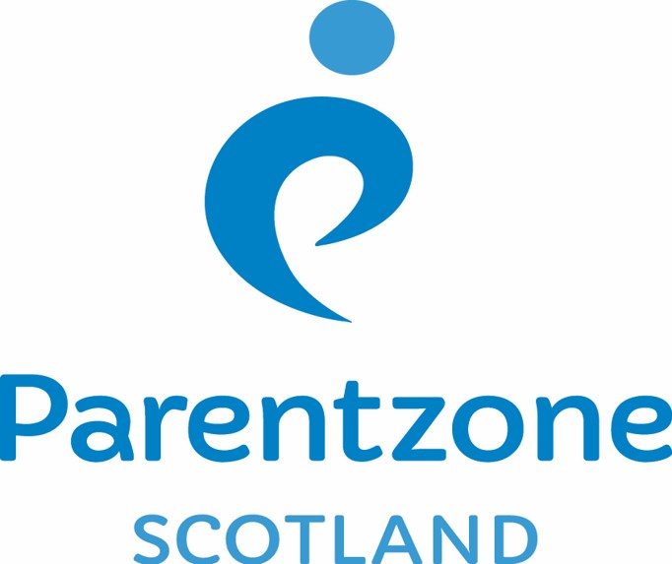
Parentzone Scotland is a one-stop shop website for information and advice on education and learning in Scotland. The website continues to be updated and improved and can be accessed at https://education.gov.scot/parentzone.

Why not check out the website for ideas on how you can support your child's learning.

Read, Write, Count

The Read, Write, Count programme aims to support parental engagement in literacy and numeracy. Gift bags are distributed annually to all P2 and P3 pupils in Scotland by Scottish Book Trust. The gift bags contain essential literacy and numeracy materials to support children’s learning, as well as advice and support to parents.

Studies show a direct link between a strong family learning environment and progress in reading, writing and counting. In addition to the parent guide included in the gift bags, the Parent Club website https://www.parentclub.scot offers a range of hints, tips and advice to help parents engage in their child’s learning

First Minister’s Reading Challenge

The First Minister’s Reading Challenge is an inclusive, exciting programme for all children – fostering a love of reading for pleasure. Research shows that reading for pleasure is crucially important for children’s development.

The Challenge is open to all local authority and independent primary and secondary schools across Scotland, as well as libraries and community groups. You can find out more information on the Challenge and also how schools can register to take part at https://www.readingchallenge.scot.

A reading app called Bookzilla, aimed at S1-S3 pupils, helps them find and recommend books and to set themselves reading challenges.

SCHOOL ETHOS

In our school we are committed to providing appropriate opportunities for the development of pupils’ spiritual, moral, social and cultural values through both the ethos and the curriculum. This will be undertaken in partnership with parents/carers and will take account of the individual needs of pupils and the views of parents/carers.

The vision, values and aims have been established following consultation with students and staff and parents.

Vision

The school offers the highest standard of education it can, striving to ensure every young person flourishes and achieves their full potential and develops the skills and attributes to lead successful and content lives in adulthood.

This vision ties in with the purpose of Curriculum for Excellence, which is to help young people to become:
- Successful learners
- Confident individuals
- Responsible citizens and
- Effective contributors

Values

Support Challenge Effort Respect

Safety Resilience Aspiration

Aims
To achieve this vision and to live and work by these values, Islay High School should be a school where:

- Students feel safe, have good relationships with staff and peers, feel confident they will get support when they need it but know that they will be challenged in their learning, thinking and development.
- Student development is tracked and monitored by appropriate teachers through academic, vocational and personal achievement but also by a prescribed set of skills founded on the principles of Mediated Learning.
- Students have a genuine say about how the school is run through the Student Leaders and Student Council.
- Leadership permeates throughout the school. While the vision, aims and strategic decisions of the school are led by the Head Teacher, these are developed in collaboration with staff, students and parents. Any member of staff can take on a whole school leadership role.
- Staff are confident in their jobs in an atmosphere of trust, knowing they will be supported by the Head Teacher and senior members of staff when needed, are reflective in their practice and motivated to develop their professional skills. They understand that there are high expectations of them as professionals. There is a high degree of consistency by staff in their professional practice. They are encouraged to be creative, collaborative and innovative in order to inspire students to achieve their best in all aspects of their lives.
- Parents are well informed of their children’s learning and what happens in the school more generally. They feel they are listened to by the school and that any issues or concerns raised are dealt with promptly. They are encouraged to take an active role in the school. They trust and support the school in maintaining good discipline.
- The school is a vibrant and central part of the community and that everyone in the community understands that the development of our young people is a shared responsibility between schools, parents and the community itself. There are a wide range of partnerships between the school and organisations in the community (colleges, businesses, estates, distilleries, trusts, etc).
- The learning and teaching is the most important aspect of the school and is constantly evaluated and improved where possible to ensure it is of the highest quality. It is positive, dynamic, fosters independent learning and creativity and learners develop and understand the skills of learning.
- The building is clean, tidy and orderly and is fit for purpose. It encourages learning, creativity and positive social interaction.
- The curriculum offers as wide a range of courses at as many levels as possible given the resources available in the school. It meets the needs of the most able to the least able. It offers pathways in both academic and vocational education.
- The school offers a good progression in Gaidhlig for Bowmore Primary School students who have attended the Gaelic Unit. Where possible, these students will be taught Gaidhlig separate from the Learners’ Gaelic class. Gaelic is encouraged, supported and promoted throughout the school.
- There is a vibrant vocational education delivered with courses which have equal status to academic courses. The courses are developed and delivered in partnership with appropriate organisations and businesses on the island so students develop the required skills to be successful in whatever college course, trade, job or business they go into.
- Ensure that each student continues to be issued with their own tablet PC and ensure that digital technology is used to enhance the quality of learning and teaching, encourages creativity and improves communication and efficiency of operational systems.
- The school offers as wide a range of extra-curricular activities as possible including residential trips, providing opportunities to students for wider achievement. The school recognises and values the role that community clubs and youth organisations also offer young people with regard to wider achievement.

Our school welcomes and encourages diversity and individuality, while emphasizing our common commitment to moral values such as honesty, respect for others, compassion and justice. Fundamental principles of our school are that all who are involved in the life of our school have the right to be respected as individuals and carry the responsibility to act in a considerate and respectful manner towards others. We are firmly committed to the elimination of any form of discrimination on the grounds of race, religion, gender or disability.

School and Community Links

IHS takes pride in the strong links it has with the community. We have many members of the community who provide support in school and many of our students are involved in supporting and running community events. We value the support that many local businesses provide to the school and work closely with many businesses and organisations to run events in school or providing opportunities for things like work experience.

We also work very closely with Social Work, Health and the Police to support the welfare of all the pupils in the school.

Promoting Positive Behaviour

Good behaviour is essential to good learning. The general aim of the school is to provide an atmosphere of mutual respect and collective responsibility. Pupils, parents/carers and staff all have an important part to play in producing and sustaining this positive ethos. The rules of the school are of a common sense nature, bearing in mind the interest and safety of all concerned.
Islay High School fully promotes appropriate behaviour for learning. The school uses Assertive Discipline theory and practices in order to promote appropriate behaviour and where necessary to model such behaviour.
A high standard of behaviour is expected both in and out of class. Promoting high standards of behaviour is the duty of all members of the school community.
Undesirable behaviour is first dealt with by the immediate member of staff, if this persists or escalates it will be passed to the relevant promoted staff, more serious issues will be dealt with by a member of the senior staff.
Persistent patterns of poor behaviour will be identified and the school will work closely with parents to design solutions or provide different types of support.
We have a merit and de-merit system in place which is used to monitor behaviour across the school.

Our school rules are as follows:-

Students are required to:
- Treat everyone with respect
- Treat the school property and other people’s property with respect
- Remain in the school grounds during morning interval
- Remain in designated social areas (canteen, assembly hall, library or outside) before registration, interval and lunch times. Students should not circulate or congregate in the corridors
- Personal mobile devices are to be used appropriately in the designated social areas and can only be used in a classroom with express permission from the teacher
- With the exception of bottles of water, all food and drink should be consumed in the canteen or assembly hall only
- For health reasons, Fizzy/energy drinks are not allowed to be consumed in the school building and should not be brought in to school.

Discipline

See above “promoting Positive Behaviour

Anti-Bullying

Argyll and Bute’s Anti-Bullying Policy may be viewed at: https://www.argyll-bute.gov.uk/sites/default/files/anti-bullying_policy_july_2019.pdf

The school’s Anti-Bullying policy closely follows that of Argyll and Bute’s policy. A copy of the school’s policy can be viewed on the school website at: Respect For All - Anti Bullying | Islay High School - Ard Sgoil Ile.

Celebrating Achievement

Children work hardest when they know their work will be appreciated and praised. All staff encourage pupils at all times and in all activities to give their best. Their effort may be rewarded verbally by praise, or non-verbally by a smiley face or sticker.

The whole school celebrates achievement by giving certificates to award pupils for good work, effort or kindness shown to others.

Wider-Curricular Activities

The school runs a variety of extra-curricular clubs throughout the year, these are published in school and updated on a regular basis. There are also many opportunities for students to get involved in additional activities working with local partners (e.g. Health and Youth Work). We plan a variety of trips throughout the year and students are given every opportunity to be involved in local and national events.

Pupil Council

The pupil council is made up of representatives from each of the tutor groups elected by their peers. The organisation of the student council and the meetings themselves are facilitated by a member of staff. The council meets about 2-3 times a term.

CURRICULUM FOR EXCELLENCE (CfE)

Curriculum for Excellence (CfE) is the Scottish National Curriculum which applies to all children and young people aged 3-18, wherever they are learning. It aims to raise achievement for all, enabling children and young people to develop the skills, knowledge and understanding they need to succeed in learning, life and work.

The Four Capacities - the curriculum aims for all children to become:

- Successful Learners
- Confident Individuals
- Responsible Citizens
- Effective Contributors

The Eight Curriculum areas are:

- Expressive Arts – including art and design, dance, drama and music
- Health and Wellbeing – mental, emotional, social and physical wellbeing; PE; food and health; substance misuse; and relationships, sexual health and parenthood
- Languages – listening and talking, reading and writing in English and modern languages, plus classical languages and literacy, and Gaidhlig/Gaelic learners (where available)
- Mathematics – including analysing information, solving problems and assessing risk
- Religious and Moral Education (denominational and non-denominational) – learning about Christianity, other world religions, and developing values and beliefs
- Sciences – understanding important scientific concepts across planet Earth, forces, electricity and waves, biological systems, materials and topical science
- Social Studies – understanding people, place and society in the past and present including history, geography, modern studies and business education
- Technologies – including computing science, food, textiles, craft, design, engineering, graphics and applied technologies

Additional important themes across the curriculum are creativity, enterprise and global citizenship, which include sustainable development, international education and citizenship.

Learning Opportunities

Your child will learn in a variety of different contexts and groups including ability, co-operative and social.

Curriculum Levels

There are national levels to describe different stages of learning and progress. For most children the expectation is:

- Early Level – early learning and childcare to the end of P1
- First Level – to the end of P4
- Second Level – to the end of P7
- Third and Fourth Levels – S1 and S2, with the fourth level broadly equivalent to SCQF level 4 (In most other Scottish schools this includes S3 as well)
- Senior Phase – S3-S6, and equivalents in other settings, where pupils/students can continue to develop the four capacities and achieve qualifications (In most other Scottish schools the Senior Phase does not start till S4)

The Senior Phase

The Broad General Education in Islay High School continues from S1 to the end of S2. All children will develop an S2 profile that describes their learning and achievement. During S2 (normally March or April), pupils will be asked to choose the courses that they will follow in S3. It is these S3 choices that lead to national qualifications.

Each school will design a senior phase that best meets learners’ needs, whether that is continuing in school, learning full or part time in college, community learning or work-based learning or a combination of these. For example, it may be possible to pick up specialist subjects and work placements that can help young people get real experience of the industry or sector that interests them.

Each young person will, in practice, have discussions with teachers and parents/carers to discuss and decide the subject choices that best suit them for the Senior Phase.

Skills for Learning, Life and Work

The development of the skills for learning, life and work are the responsibility of all practitioners and include literacy, numeracy and associated thinking skills; health and wellbeing, including personal learning planning, career management skills, working with others, leadership and physical co-ordination and movement skills; and skills for enterprise and employability.

Through Curriculum for Excellence children and young people are entitled to a continuous focus on literacy, numeracy and health and wellbeing. These skills are essential if children and young people are to gain access to continuous learning, to succeed in life and to pursue a healthy and active lifestyle. The use of ICT underpins these overlapping and mutually supportive skills sets; ICT skills will continue to be developed in a variety of contexts and settings throughout the learner’s journey.

All children and young people are entitled to opportunities for developing skills for learning, life and work. These skills are relevant from the early years right through to the senior phase of learning and beyond.

16+ Learning Choices

16+ Learning Choices is a guaranteed offer of a place in post-16 learning for every young person who wants it. This is the Scottish Government’s model for helping young people to stay in learning after the age of 16.

16+ Learning Choices looks to help reduce youth unemployment in Scotland and to contribute towards economic growth. 16+ Learning Choices seeks to equip all young people in Scotland with the skills and knowledge they need post-school to achieve their full potential and find a positive destination in further education, training or employment. 16+ Learning Choices is seen as an integral part of Curriculum for Excellence.

The Pupils’ and Parents’ Voice

Personalisation and choice is one of the seven principles of curriculum design and children and young people throughout their education will have the opportunity to discuss with their teacher the context in which they learn and how they will approach the learning. Staff will discuss new learning with the children at the beginning of a new topic and plan together the areas of specific focus, e.g. World War 2 – The Battle of Britain. This will be shared with parents/carers through the homework diary and parents/carers will be invited to support the learning by sharing resources from home, e.g. a ration book, or by visiting the school to deliver a talk.

Parents/carers will be invited to share comment regarding the planned work for their child at various points throughout the year and are encouraged to feedback comment at any time through their child’s homework diary.

The Curriculum at School, Local and National Level

Detailed information on the curriculum is shared with parents and students at critical times throughout the school year. Please contact the school if you would like further information or view the information on the school website.

Careers Information Advice and Guidance

Through partnership working, schools plan with a variety of organisations to ensure that career information, advice and guidance are an integral part of the curriculum. This provides children and young people with real and relevant learning opportunities that can be applied both in and beyond the classroom.

Islay High School has a close partnership with Skills Development Scotland (SDS) and they have a permanent representative based in the High School. This person rans career workshops with all year groups and also provide 1:1 interviews with specific pupils who are struggling to know what to do when they leave school. The school works closely with SDS to try and ensure that every pupil leaves school with a positive destination.

Financial Guidance

From S4 onwards, financial guidance is given to pupils and is covered in the tutor programme. S6 pupils, and any other pupils known to be leaving school, are given one whole day of workshops dedicated to raising awareness of financial matters and ensuring pupils are well-prepared for coping with their finances, when they leave school.

Sexual Health and Relationships Education

Sexual Health and Relationships Education is part of Health and Wellbeing. The main areas covered are:
- Respecting themselves and others
- Respecting individual differences
- Ways of expressing and dealing with feelings and emotions
- Ways of keeping safe
- Positive and supportive relationships

These areas are recommended by Scottish Government and are age and stage appropriate.

An effective programme of education about Sexual Health and Relationships is best built on parents/carers and schools working in partnership and assuming shared responsibilities. We aim to keep parents/carers informed about the nature and purpose of the learning programme their children will follow, and to seek parents’/carers’ views at appropriate times. Any parents/carers who do have any questions or concerns should contact the Head Teacher directly.

Drugs Education

In accordance with the Scottish Government guidelines and Argyll & Bute Council Education Department policy and practice, and in common with all Argyll & Bute schools, this school has in place procedures for dealing safely and effectively with drug-related incidents.

No pupils are allowed to smoke, vape, drink alcohol or take drugs on school premises. Any pupil discovered doing so, will be spoken to by a senior member of staff and parents will be informed. The school will do everything it can to explain the dangers of these substances and support a pupil to stop. If it continues to occur, it could lead to temporary exclusion.

Further information can be obtained by contacting the Head Teacher or via www.argyll-bute.gov.uk/social-care-and-health/argyll-and-bute-addiction-team-abat.

Religious and Moral Education

The programme for Religious Education in our school aims to help pupils learn about Christianity and other major world religions and to recognise religion as an important part of human experience. Pupils will also be encouraged to learn from religions and helped to develop their own beliefs, attitudes, moral values and practices through a process of personal search, discovery and critical evaluation.

Please note that parents/carers have the right to withdraw from religious observance / education. If a parent /carer wishes to withdraw their child from Religious and Moral Education classes or attendance at school assembly or church services they should contact the school and discuss their concerns with the Head Teacher.

ASSESSMENT

Assessment is crucial to tracking progress, planning next steps, reporting, and involving parents/carers and learners in learning. Evidence of progress can be gathered by learners themselves and by fellow pupils (peers), parents/carers, teachers and other professionals.

A number of approaches are employed including the following:

- Self-assessment – learners will be encouraged and supported to look at and revisit their own work to develop a better understanding of what they have learned and what they need to work on
- Peer assessment – learners will be encouraged and supported to work together to help others assess what is good about their work and what needs to be worked on
- Personal learning planning – children, teachers and parents/carers will work together to develop planning for next steps in learning
- Profiles – a statement of achievements both within and out with school, to be introduced at P7 and S3.

Your child’s progress is not only based on ‘tests’ but on the learning that takes place within the classroom and in different settings out with the classroom.

Evidence of children and young people’s progress and achievements will come from day to day learning and through the things they may write, say, make or do. For example, evidence may emerge as a result of children and young people taking part in a presentation, discussion, performance, or practical investigation. Evidence may be captured as a photograph, video or audio clip as part of a particular learning experience.

Assessment takes place as part of ongoing learning and teaching, periodically and at key transitions.

The Scottish National Standardised Assessments (SNSA)

From August 2017 the Scottish Government has introduced a single, nationally developed set of standardised assessments, designed to reflect the way we deliver education in Scotland, through Curriculum for Excellence. These assessments are expected to replace the variety of existing standardised assessments that local authorities and schools use at the moment.

Ongoing and informal assessment is, and will continue to be, a central part of everyday assessment. Teachers will continue to draw on all of the assessment information available to them, when considering children’s progress and planning the next steps in their learning.

SNSA focus on aspects of reading, writing and numeracy and children in P1, P4, P7 and S3 will be assessed. P1 children will take two SNSA assessments: one in literacy and one in numeracy. P4 children will take three SNSA assessments: one in reading, one in writing and one in numeracy. P7 children will take three SNSA assessments: one in reading, one in writing and one in numeracy. S3 young people will take three SNSA assessments: one in reading, one in writing and one in numeracy. Please note that some pupils will not access SNSA due to their specific additional support needs.

The online assessment system will produce feedback information about where your child did well and where further support is required. Your child’s teacher will use this feedback to help plan next steps and provide further support as appropriate. Providing the right support at the right time will help to ensure your child can reach his or her potential.

REPORTING

Reporting informs parents/carers of progress in learning and achievement. This will be through a range of approaches including meetings at parents’ evenings or in written form. There will be 4 occasions where teachers will report back to parents during the academic year. Each pupil will receive an interim report early on in the session and then a full report round about two thirds through the session and then there will be two Parents’ Evenings interspersed between the written reports.

Parents will get regular information about their children's strengths, progress and achievements. This will take account of their achievements in key areas of learning such as literacy and numeracy and in different contexts and settings including across curriculum areas, the life and ethos of the school, and learning outwith the school, including the wider community. At key points this will include information on the curriculum level children are working within and progress towards qualifications in the senior phase. Parents will be informed of what their children need to do to continue making progress and ways that they can help.

At P7 and S2, teachers will work with children and young people to prepare profiles which will highlight their achievements over a period of time and summarise their learning journey at key points of transition.

TRANSITIONS

Transitions are the moves children and young people make from home to nursery, from nursery to primary, from primary to secondary, from secondary to further education and beyond.

Transfer to Secondary School

Primary school pupils normally transfer to their catchment area secondary school in August following completion of their P7 year. Secondary staff visit P7 pupils to discuss aspects of their transfer with them and in June the pupils will spend an agreed length of time at their prospective secondary school.

You will be contacted by letter and offered a place for your child at Islay High School, which you may either accept or decline. Secondary schools have their own arrangements for meetings with prospective parents/carers, and you will be given details of these meetings.

Should you prefer your child to attend a school other than the designated catchment area school then a Placing Request must be made. Forms are available from the Head Teacher, or by contacting School Support by email to argyllhousereception@argyll-bute.gov.uk or by ‘phoning 01369 704000.

Moving from Stage to Stage

Your child will be involved in an induction programme every year in school. Prior to the summer holiday your child will meet their teacher/s for the following session and visit their new classroom/s. Teachers work closely and share information about your child’s learning and achievements. Staff will also share other information which will help the teacher support your child’s learning, e.g. friendship groups, preferred ways of working, etc.

Moving Between Schools

When a child moves to a new school their class teacher will normally telephone the new school to share information on academic achievement and personal likes/dislikes with their new teacher. Parents/carers are encouraged to organise a visit to the new school (if possible) in advance to support the child feel secure in the move.

It should be noted that opportunities for enhanced transitions are available for children as required.

Liaison with Local Schools

Our school maintains close links with local primary schools. Our teachers, and in some cases our pupils, visit other schools and establishments and other teachers and pupils visit us. This process is important for the professional development of staff, reciprocal understanding and the establishment of curricular consistency.

Leaving School

The first eligible school leaving date for most young people is 31 May at the end of S4. This applies to young people whose fifth birthday fell between 1 March and 30 September in the year they entered P1. Younger pupils in a year group are required to stay on until December in S5. Older pupils are eligible to leave as early as December in S4.

Opportunities for All is the Scottish Government’s commitment to offer all 16-19 year olds a place in education, training, employment or other planned learning from when they leave school up to their 20th birthday. All young people should receive the right amount rather than the same amount of information, advice and support in order to help them enter and sustain a positive destination. For young people who do not immediately enter a positive destination on leaving school, support will continue until they find a suitable opportunity.

Transitions are particularly critical for young people with additional support needs and require additional preparation and planning. Whenever a young person with additional support needs is approaching a transition, other agencies are involved in transition planning, the young person's views are sought and parents/carers will be part of the planning process. In all cases, early consultation will take place with the post-school learning provider to ensure that any support necessary is in place.

SUPPORT FOR PUPILS

Support Arrangements for All Pupils

Providing personal support for learners 3-18 is the responsibility of all staff. In the early learning and childcare and primary setting the early years practitioner or class teacher is the key adult who knows every child or young person in their care well, taking an avid interest in their welfare and progress.

In the secondary setting it is Guidance staff who play an active role in promoting learners’ personal, social and academic welfare; this is supported by Pupil Care and Support staff who offer help, support and advice as required, safeguarding the health and wellbeing of learners.

Identifying and Addressing Additional Support Needs

The Argyll & Bute Staged Intervention Framework is used to identify and meet pupils' needs and to manage and review provision. This follows the Getting it right for every child (GIRFEC) practice model. GIRFEC is a national framework to help all children and young people grow, develop and reach their full potential. Its focus is to improve outcomes for children and their families based on a shared understanding of their wellbeing.

Every child in school will have a Named Person. In primary school this will usually be the head teacher and usually a principal teacher of pupil support or depute head teacher in a secondary school. The Named Person will usually be the first point of contact for parents if they have any concerns about their child at school. The Named Person will work with parents to provide support to meet a child’s needs or resolve concerns. If there is a need to involve more than one agency to work together to provide support then a Lead Professional will be appointed to coordinate that support.

Where support is being provided by a single agency then a Planning meeting may be held and a Child’s Plan opened. Where two or more agencies are involved in supporting a child’s needs, then a Child’s Plan will definitely be opened. The Plan will include an assessment of the child’s needs using the My World Triangle assessment tool and a note of the agreed outcomes based on that assessment recorded on the Well Being App within SEEMIS. Parents are an integral part of this meeting and the Plan includes an opportunity to have their views recorded within it. Plans will be reviewed at appropriate intervals, again with parents as full partners in these meetings.

More information on GIRFEC in Argyll and Bute can be found at http://www.argyll-bute.gov.uk/social-care-and-health/girfec-resources.

Staged Intervention

The key principles underpinning Staged Intervention, as outlined in the Education Scotland website (https://education.gov.scot/scottish-education-system/Support%20for%20all) are as follows:

What is staged intervention?

- Staged intervention is used as a means of identification, assessment, planning, recording and review to meet the learning needs of children and young people.

- It provides a solution-focused approach to meeting needs at the earliest opportunity and with the least intrusive level of intervention. The process involves the child, parents/carers, school staff and, at some levels, other professionals, working in partnership to get it right for every child.

- Staged intervention is designed to be flexible and allows for movement between stages depending on progress.

Argyll and Bute Staged Intervention: The Stages at a Glance

Universal Support Entitlements: All learners have an entitlement to support. All children and young people should have frequent and regular opportunities to discuss their learning with an adult who knows them well and can act as a mentor, helping them to set appropriate goals for the next stages in learning. Young people themselves should be at the centre of this planning, as active participants in their learning and development. Robust systems for assessing, monitoring and tracking are key within this stage.

Stage 1 – In-class or in-group.
The class teacher or key worker (Early Years) identifies a need for some additional support. The Named Person is notified and the teacher /key worker makes some changes to the normal routine or gives some extra attention so that the child can get the best out of the work of the group or class.

Stage 2 –Targeted intervention.
There is an identified need for targeted planning and intervention to address additional support needs.

A Child’s Plan may be in place outlining the specific targeted interventions required and detailing long- and short-term outcomes and timescales. Timescales for review of the interventions will be built in to the plan. There are likely to be termly reviews of short-term targets and annual reviews of long-term targets.

Additional support at this level may include (in addition to supports available at Stage 1):

- new resources being accessed for use by the whole class/group;
- small groups being created for additional tuition;
- an individual programme of work being introduced;
- a short term programme of individual support being put in place.

Classroom or Pupil Support Assistants may be deployed to help deliver these supports.
Stage 3 – Specialist input.
There is an identified need for more targeted intervention and/or specialist provision and interventions including:
• a high degree of individualisation of learning and/or
• access to a different learning environment
• substantial adaptation to the curriculum and/or
• substantial adaptation to the learning environment.

A Universal Child’s Plan will be in place outlining the specific targeted interventions required and detailing long- and short-term outcomes and timescales. Where there is multi-agency involvement, a Lead Professional will co-ordinate this support. There may also be a Co-ordinated Support Plan in place.

Further Information about Additional Support Needs (ASN)

Local, direct support is usually the best way to meet pupils' needs. If parents/carers have any questions about their child's progress or well-being at school, they should discuss these first with Dr Janice Weatherhogg or Ms Karen Siddall. Please contact the school office to arrange an appointment.

The level of support for pupils with ASN depends very much on degree of need. In some case the extra support might be just from the teacher. This might be the case for many pupils with dyslexia. There may be and ASN assistant in class either supporting the whole class or just one or more individuals on a 1:1 basis. Alternatively a pupil may be extracted from certain parts of the curriculum so they get 1:1 support either from an ASN Teacher or an ASN Assistant, supported by a teacher.

This school values partnership working with parents/carers and will do everything possible to help resolve concerns or differences of opinion at an early stage. If you have any queries about your child's additional needs, or about the support being provided to meet those needs, please contact the Head teacher.

Parents/carers and young people have the right to ask the Education Authority to establish if a pupil has Additional Support Needs (ASN) and consider if a Co-ordinated Support Plan (CSP) is needed. This should be raised with school staff in the first instance or can be sent in writing by emailing the Educational Psychology Service to educational.psychology@argyll-bute.gov.uk describing the type of assessment and why it may be necessary. Alternatively, please call 01369 708537 for more information. Requests are acknowledged promptly and usually agreed unless the request is considered to be 'unreasonable'.

Parents/carers can also arrange an assessment privately and ask the Education Authority to take the assessment report into account.

Parents/carers and young people have the right to:
- Independent Mediation Services
This service is free and involves an independent third party who helps to resolve disagreements between the Education Authority and parents/carers or young people.

- Independent Advocacy
Take Note is the National Advocacy Service for Additional Support Needs, established by the Scottish Government and provided jointly by Barnardo’s Scotland and the Scottish Child Law Centre. It offers independent professional or legal advocacy to families and young people who have grounds to make a referral to the Additional Support Needs Tribunal Scotland. More information is available by telephoning 0131 667 6333 or by email to enquiries@sclc.org.uk.

- Free Dispute Resolution
Some disagreements, such as about the assessment of additional support needs or the level of support, can be referred for written review by an adjudicator independent of the council. Requests for Dispute Resolution should be made to Louise Connor, Head of Learning and Teaching/Chief Education Officer via Louise.Connor@argyll-bute.gov.uk. If you do not have access to email, please contact Louise Connor by phone on 01631 569196.

- Referral to the Additional Support Needs Tribunal Scotland (ASNTS)
Parents/carers and young people can appeal to the ASNTS about decisions involving a Co-ordinated Support Plan (CSP) http://www.asntscotland.gov.uk (0845 120 2906).

A new national advocacy service provides advice to parents/carers and young people about grounds for a referral. Contact Barnardo's, 235 Corstorphine Rd, Edinburgh EH12 7AR www.barnardos.org.uk.

Independent advice and information is available from Enquire, the Scottish Advice Service for ASL http://enquire.org.uk/ (0845 123 2303).

The Govan Law Centre Education Law Unit works in partnership to support pupils' and parents'/carers’ rights in education. Contact Govan Law Centre, 47 Burleigh Street, Govan, Glasgow G51 3LB. 0141 445 1955 https://govanlawcentre.org/education-law-unit/

The Scottish Independent Advocacy Alliance safeguards people who are vulnerable. Contact Melrose House, 69a George Street, Edinburgh, EH2 2JG. 0131 260 5380 http://www.siaa.org.uk

SCHOOL IMPROVEMENT

Main Achievements

The focus over the last 2 years, has been to concentrate on supporting pupils through. not only their academic progress, but also their mental health and general well-being during the coronavirus pandemic.

The majority of pupils have come through the two lockdowns, together with the blended and home learning, incredibly well and have shown tremendous resilience in doing so. However, a small but significant number of pupils have struggled and there is clearly an increase in anxiety and stress among this group of pupils. We are now also seeing an increase in school refusers and attendance has dropped as a result. Every effort is being made to support these pupils and the school is using all available resources (PEF funding) and partners (School nurse, MAYDS counsellors, A&B counsellors, Educational Psychologist and CAMHS) to provide this support.

The staff, both teaching and non-teaching, have been remarkable. They have pulled all the stops out to ensure that whatever the circumstances, the teaching has continued, the pupils (and their families) have been supported whether that be in school or at home. Incredibly, despite the enormous challenges, the rapid changes and the stresses of the situation, the morale and wellbeing amongst the staff has remained high. They all deserve a huge amount of credit for what they have achieved.

The school adopted Microsoft Teams to deliver courses during the two lockdowns for home learning as well as during the period of blended learning. This generally worked very well. Separate timetables were set up for the period of home learning during the lockdown and for the period of blended learning. Teachers adapted and learnt very quickly how to make the most of MS Teams. Fortunately all our pupils are issued with their own tablet devices so that was never an issues. The main issue for a small minority of families was poor connection on the island in specific areas and this has not been resolved.

The biggest success has been how well the school community has pulled together through this pandemic and we’re coming out of this pandemic stronger and more resilient as a result.

Improving Standards

As stated above, pupils have struggled with the 2 lock-downs and the continued disruption as a result of the covid pandemic. As a result standards have not improved with regard to literacy, numeracy and health and well-being. A significantly greater number of pupils are now suffering from mental health issues, overall attendance has dropped and there are significantly more pupils struggling to get into school.

School Improvement Plan

The following table outlines the key priorities for the school this session:

Priorities | Proposed Impact | Measures | Linked to PEF (Y/N)
- Ensuring the highest standards in learning and teaching. | Professional library in place, all staff using an agreed and updated self-evaluation toolkit and all staff developing aspects of their teaching they want to improve. | Observations | No
- Digital technology for remote learning | All coursework material can be accessed by pupils at home at any time through Microsoft Teams | All pupils can access work from home if and when required | No
- Improve stakeholder engagement | Key priorities of the SIP are shared with all stakeholders and they are then consulted and involved in next session’s key priorities | All stakeholders are aware of the key priorities, had the opportunity to evaluate progress and give views for next session’s key priorities | No
- Young people’s health and wellbeing - implementing Seasons For Growth programme | Key staff are trained and given time to deliver the programme to pupils | At least two groups of pupils go through the programme | No
- Further Promotion of the Gaelic Language and Culture within IHS and the Wider Community | Further Promotion of the Gaelic Language and Culture within IHS and the Wider Community | Rationale and priorities document is written and shared, Gaelic signage round the school is improved, GME pupils’ attainment is recorded in SEEMiS, extra-curricular activities and events delivered, offer all pupils opportunity to learn Gaelic, links are made to all other secondary schools with GME pupils, transition plans in place for GME pupils moving from BPS to IHS. | No
- Pupil Equity funding: Improving attendance | Teacher employed 0.2 FTE to monitor and record attendance and to work with pupils and their families to improve attendance. | Attendance of pupils is by nearly all pupils over 90% | Yes

School Performance

SQA Results
Levels A to C Levels A to D
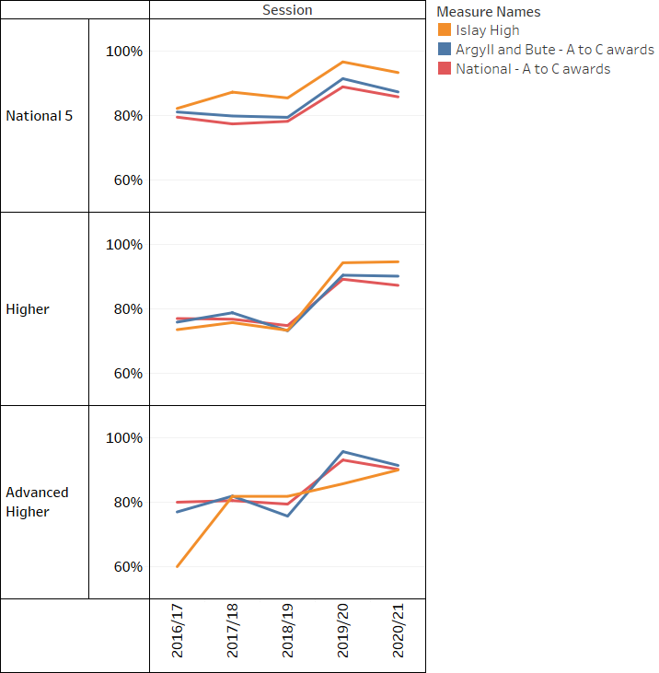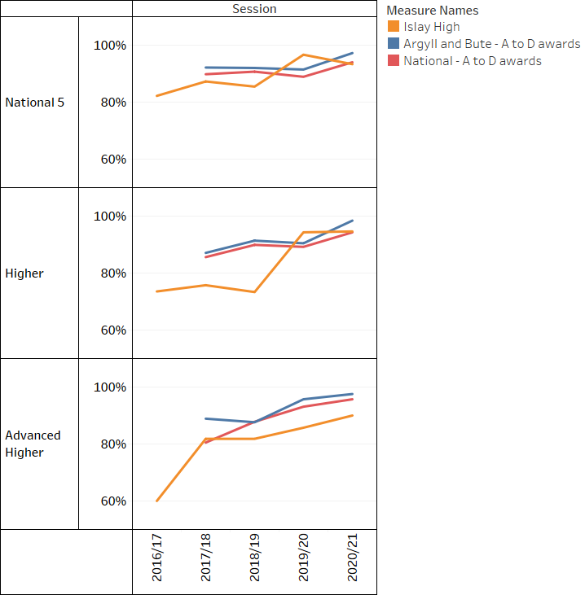
As you can the percentage pass rates for Higher and National 5 are very good and significantly surpass the Argyll and Bute as well as the National averages. However, this is not a particularly valuable measure of attainment. The Advanced Higher results are not statistically significant due to the low numbers taking these courses.

Breadth & Depth
The chart below shows SQA Breadth and Depth information for S4 to S6 (Acc)
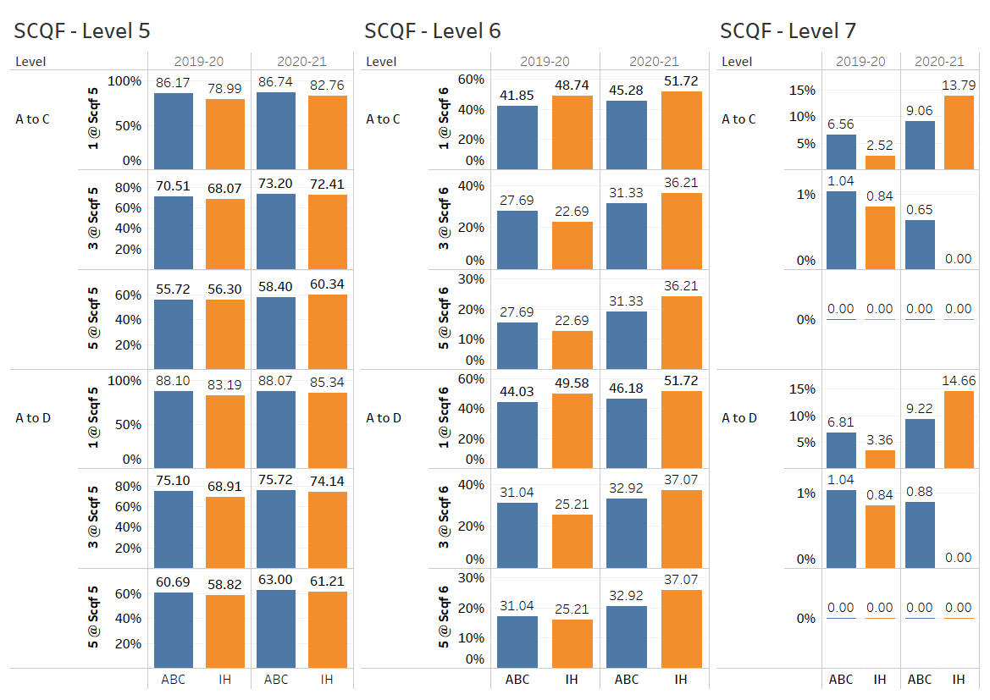
There is a marked increase in SCQF values from 2019 to 2020 at National 5 and an even more marked increase at Higher level. This can be attributed to changes in ability levels between cohorts. In addition to that, attainment was assessed differently from 2020 to 2021 and therefore it is very difficult to make any valid conclusions.

Attendance and Exclusion

Measure | 16/17 |  | 17/18 |  | 18/19 | 19/20 | 20/21 | Range of Attendance (%) over 5 years⁸
Attendance:
Attendance (% of school roll) | 93.11% |  | 93.89% |  | 93.33% | 90.61%
Authorised Absence (% of school roll)⁸ | 3.93% |  | 4.49% |  | 4.76% | 6.83%
Unauthorised Absence (% of school roll) | 3.11% |  | 2.40% |  | 1.91% | 2.55%
Attendance Number of Pupils (%) - Authority Average¹ | 91.58% |  | 91.24% |  | 90.3% | 90.01%
Attendance Number of Pupils (%) - National Average⁹ | 91.2% |  | Not collated |  | 90.7% | Not collated
Measure | 16/17 |  | 17/18 |  | 18/19 | 19/20 | 20/21⁶
Exclusions:
Exclusion Openings - number | 5 |  | 4 |  | 0 | 0 | 0
Exclusion Incidents - number | 2 |  | 1 |  | 0 | 0 | 0
Number of Pupils | * |  | * |  | 0 | 0 | 0

The drop in attendance from 2019/20 to 2020/21 will primarily be down to the increased anxiety and stress levels on a significant number of pupils. I would expect the attendance levels to drop even further in 2021/22.

For the third year running, we have avoided any need for exclusions.

SCHOOL POLICIES AND PRACTICAL INFORMATION

Early Learning and Childcare Meals

Health and Wellbeing is a large part of the ELC experience, and includes access to milk, a healthy snack and meal time provision. We are committed to providing healthy, nutritious, good value meal options to children in our Early Learning and Childcare Settings. If your child is in ELC for more than four hours and over a lunch period they are entitled to a funded nursery lunch.

Our ELC lunch offer is a two course menu with a main meal, and will be either a starter and a main course, or a main course and a dessert. The menu runs on a four week cycle so that there is plenty of choice for children.

Our ELC menus comply with the Scottish Government's guidance, Setting the Table. In this document there is guidance on healthy snack options, meal planners and foods that are not acceptable for inclusion in provision, as well as other helpful guidance. The link to this document is:

http://www.healthscotland.com/uploads/documents/30341-Setting%20the%20Table.pdf

Scottish Milk and Healthy Snack Scheme (SMHSS)

The SMHSS funds a daily portion of plain fresh cow’s milk (or specified alternative) and a healthy snack (fruit or vegetables) for all pre-school children spending two hours or more in the care of a regulated day care provider and/or childminders that have registered for the SMHSS. SMHSS will replace the current UK Nursery Milk Scheme from 1 August 2021.

The link to this guidance is:

Milk and Healthy Snack Scheme (Scotland) Regulations 2021: children's rights and wellbeing impact assessment - gov.scot (www.gov.scot)

School Meals

Argyll and Bute Council is committed to providing healthy, nutritious, good value meal options to pupils in our primary and secondary schools and a school meal is available in almost all of our schools, with the exception of Iona and Ulva primaries. We encourage healthy eating and school lunches are planned so that children can choose a well-balanced meal and a good selection of bread, vegetables, fresh fruit, fruit juice and milk are available daily. All of our menus comply with the Scottish Government's Schools (Health Promotion and Nutrition) (Scotland) Act 2007 https://www.gov.scot/policies/schools/wellbeing-in-schools/ and with Nutritional Requirements for Food and Drink in Schools (Scotland) Regulations 2008 https://www.gov.scot/publications/healthy-eating-schools-guide-implementing-nutritional-requirements-food-drink-schools-9780755958306/pages/0/.

As part of Scottish Government legislation, from January 2022 all pupils in P1-P5 will be entitled to a free school meal. Parents do not have to register for this; all pupils will receive this meal automatically. Please see the section on free school meals for information for pupils from P6 and beyond.

Allergy information for our school menus is available online and in each school kitchen. You can find out the allergens contained in every dish, and by clicking on the links for each meal you can also find out the recipe used, full ingredients and nutritional information. These are available via https://www.argyll-bute.gov.uk/primary-school-meals-menu. If your child has a food allergy, please contact the school office in the first instance so that any necessary arrangements can be put in place.

A vegetarian meal option is available every day, and many dishes can be altered to accommodate other special diets where this is required. Where possible, other non-medical special diets may be accommodated; please contact the Food and Nutrition Officer for more information.
Islay High School operates a cashless catering system. All pupils are issued with an account and parents are able to input money through Argyll and Bute’s website via the following link:
https://ip.e-paycapita.com/AIP/accountSearch.do?link=showAccountSearchPage&requestId=nw2u0jlymya92sfumrndhl076cduyq2

Secondary Schools:

Across our secondary schools, pupils can opt for a two course set meal, which costs £2.40. In addition, secondary schools offer a range of hot and cold snacks and meal deals at lunch time. A selection of hot and cold items are also available at mid-morning interval. Secondary meals can be pre-ordered, to minimise queuing at lunchtime.

Menus are designed specifically for each individual secondary school. A copy of the menu can be obtained from the school and may also be available on the school’s website.

Packed Lunches

Some pupils prefer a packed lunch and it is the Authority’s policy to provide facilities for the consumption of packed lunches in all schools where these are required. We believe a well-balanced packed lunch with a tasty alternative to chocolate biscuits and sweets is very important, although one small treat per day does no harm! Dates, raisins, sultanas, carrot sticks, cherry tomatoes and seasonal fruit could provide healthy alternatives. Unflavoured milk and water are the ideal drinks for teeth and a pure fruit drink or mineral water is better than drinks with high sugar content.

Sandwiches often form a major part of a packed lunch. Fillings for sandwiches should be chosen with care because the packed lunch will be stored in a warm classroom for a number of hours. It is therefore advisable to use a cool bag and ice pack and choose fillings that are less likely to be affected, e.g. cheese and tomato, salad, egg and tomato. An alternative to sandwiches could be cooked pasta with a variety of fruit or vegetables and a suitable dressing. Occasionally a piece of quiche or pizza could be included.

The school aims to encourage children to enjoy food which is both attractive to them and nutritionally sound, whether this is a school meal, a packed lunch or a snack. We would appreciate your support in achieving this aim.

Free School Meals
From January 2022, all pupils in P1-P5 are entitled to a free school meal. Parents do not have to register for this; all pupils will receive this meal automatically.

Free school meals are also available, via an application process, to pupils from P6 and beyond whose parents or carers receive any of the following:
- Income Support
- Income based Job Seekers Allowance
- Income related element of employment and Support allowance
- Child Tax credit but not Working Tax Credit (income should not exceed £16,105)
- Child Tax Credit and Working Tax Credit (income should not exceed £7,330)
- Support under Part V1 of the Immigration and Asylum Act 1999
- Universal Credit (monthly take home pay for period must be under £610)

A free school lunch will also be available to children who attend nursery and receive their free early learning and childcare over lunchtime if parents receive one of the benefits listed above. In addition, pupils aged between 16 and 18 years who receive any of the above benefits in their own right also qualify.

To complete an online application form please visit https://www.argyll-bute.gov.uk/education-and-learning/childcare-school-and-education-grants-0. Alternatively, please contact Customer Services: Education on 01369 708548 or your local benefit enquiry office.

As the school has adopted a cashless catering system, anonymity is ensured for any student receiving a free school meal.

Please note that the above eligibility criteria is correct at time of publishing (September 2021) and may be subject to change by the start of August 2022. The link above will contain the most up-to-date information.

If you are not eligible for any of the benefits listed above there is a separate application process available and you should contact either 01369 708548 or your local benefit enquiry office for details.

Special Dietary Requirements

Argyll and Bute Council Catering Service provides meals across all schools, including Primary, Secondary and Early Years Units. Part of this includes the provision of special dietary requirements for food allergies and intolerances, medically prescribed diets and diets for religious or cultural reasons.

If required, please contact the school to obtain a Special Diet Request form. Once this has been completed and passed to the Catering Manager, the Catering Service will, where necessary and as required, work with the pupil, Parent/Carer, Education and the NHS to provide a nutritionally balanced meal that meets the dietary requirements for the pupil. Requests for non-medically prescribed diets also require a completed Special Diet Request form.

Health Care

You can contact your school health staff at: 01496 301025

Administration of Medicines

Many pupils will, at some time in their school careers, need to take medication. For the vast majority this will be a short-term requirement, with pupils simply finishing a course of medication which has been prescribed for them by their family doctor. Wherever possible, parents/carers are requested to ask for GP prescriptions which can be administered outwith the school day, i.e. in the morning and evening.

However, pupils may have medical conditions such as asthma or diabetes which may require long-term support and, if their conditions are not properly managed by taking regular medication in school, their access to education could be limited. In addition, some children have conditions which may require occasional staff intervention, e.g. severe allergic conditions such as anaphylaxis. Pupils with such conditions are regarded as having health care needs but, notwithstanding these, the vast majority of children with such needs are able to attend school regularly and, with some support from the school staff, are able to take part in most normal school activities.

In any of these circumstances parents/carers (or young people themselves if they are over the age of 16) should discuss the matter with school staff and agree the arrangements which will be made to provide support for the pupil. A written request form must be completed in advance when any medication is to be administered or taken in school.

Skin Protection

Your child’s skin may be affected by exposure to the sun, especially over the lunchtime period and other outdoor activities. It is a good idea for your child to wear a sun hat. If they have one, please put it in their school bag.

You should ensure your child has sunblock applied prior to arriving at school in periods of hot weather and if you wish them to have further applications at lunchtime then you should send in sun-cream/block and we can help your child apply it.

Face painting is occasionally carried out within schools. Parents will be informed when this activity is being planned.

Transport

Transport to and from school is available for pupils who live more than:-

- 2 miles away from their catchment primary School
- 3 miles away from their catchment secondary School

Pupils may still be required to walk to a school transport pick up point. Primary school pupils will not be required to walk more than two miles and secondary pupils will not be required to walk more than three miles from their home to the pick-up point.

Pupils will not be picked up or dropped off at any point other than the designated location without written authorisation from a parent or carer.

Please see www.argyll-bute.gov.uk/education-and-learning/school-transport for further information on school transport.

Exceptional Requests
Consideration will be given in exceptional circumstances for school transportation where your child attends their catchment school but would not normally be entitled to transport.

Where parents/carers believe that there may be grounds for an exceptional transport request, an application form should be completed and submitted to the Integrated Transport Section. Applications will then be referred for further assessment as appropriate.

Exceptional transport requests can be made when:-

- Your child has been recommended on health grounds by a designated medical officer.

- Your child has requirements based on educational grounds / additional educational needs.

- Your child has to walk a route which, after an assessment, is considered to be unsafe for children even when accompanied by a responsible adult.

Application forms are available from the school office or you may apply on-line on the Council website at www.argyll-bute.gov.uk/education-and-learning/school-transport.

Free Bus Travel Scheme

A national new free bus travel scheme for children and young people aged from 5 to under 22 will start from 31st January 2022. Further information can found on the Transport Scotland website: https://www.transport.gov.scot/concessionary-travel/young-persons-free-bus-travel-scheme/ and parents will receive further information in due course from Education.

Education Maintenance Allowance (EMA)

EMA is a weekly payment of £30, paid fortnightly in arrears, for eligible students aged 16 to 19 who are continuing in post-compulsory education. The allowance is means-tested based on household income and is payable fortnightly in arrears during term time. Payments will be made direct to the student’s own bank account.

Further information and full eligibility criteria can be found at https://www.argyll-bute.gov.uk/education-and-learning/education-maintenance-allowance or by emailing ema@argyll-bute.gov.uk or telephoning 01369 708548.

Insurance

The Authority insures against its legal liability for:-

- accidental personal injury and,
- accidental damage to property not belonging to the school or Council.

This means that if an injury is sustained or personal property is damaged/broken/lost due to negligence or omission on the part of the school or its staff, claim costs will be met by the Council’s public liability policy. There is no automatic right to compensation. It is the responsibility of the person making the claim to prove that the Council has been negligent in their actions leading to the loss.

Parents/carers may wish to consider their own insurance arrangements in terms of appropriate extensions to their household insurance or arranging their own separate covers.

Music Services

Music lessons are available in woodwind, brass and pipes. These are free to students studying Music at National, Higher and Advanced Higher levels. There are opportunities for pupils to join the school wind and brass band, a traditional music group and school choir. These groups not only perform in school at evening concerts and school events but also regularly at community events. The school also has its own recording studio allowing pupils to record their own music at professional level.

Parental Access to Records

The School Pupil Records (Scotland) Regulations 1990
Details of the regulations and process for obtaining information specific to pupils are available by contacting the school directly. See management circular 3.11 https://www.argyll-bute.gov.uk/education-circulars

Subject Access Requests

GDPR legislation includes the right to request information we hold about you. If you wish to receive a copy of the personal information we hold about you, this is known as a Subject Access Request. Further information and a Subject Access Request form may be accessed via: https://www.argyll-bute.gov.uk/data-protection

Child Protection

Given on-going public concern on the subject of child abuse, and recent changes in the law, schools are now required to report if they think any child may have come to harm as a consequence of possible abuse.

A member of staff in each school has been appointed to be responsible for Child Protection matters and special training has been given to these people. Should you wish further advice about Child Protection and the safety of children, please feel free to contact the school.

The school has good liaison contact with the School Medical Officers, Social Workers, and the Police, any or all of whom may become involved if abuse is suspected.

Please see www.argyll-bute.gov.uk/abcpc for more information on child protection.

Weapons Incidents in Educational Establishments

A joint protocol has been agreed between Police Scotland, Argyll and Bute Council and West Dunbartonshire Council for dealing with any weapons incidents in schools. It is therefore important to make parents aware of rules and expectations in relation to weapons and the response to allegations of weapons possession. Weapons must in no circumstances be brought to school and pupils will be encouraged to share any knowledge of weapons with teaching staff.

The purpose of the protocol is to maximise the safety of children and young people and to safeguard the welfare of all persons involved in any weapons-related incident, including any alleged perpetrator, through an effective multi-agency response. All incidents involving weapons at any educational establishment where a person under the age of 18 is educated, and any incident involving a child less than 18 years being in possession of a weapon, will trigger the operational response summarised below. Every incident will be thoroughly investigated and recorded.

- In response to an incident involving possession, or suspected possession, of a weapon in an educational establishment, the Senior Management Team will react with a proportionate response. Police Scotland will be contacted immediately and will coordinate any emergency response. In the event of a serious incident, appropriate medical attention will be sought and designated First Aiders at the establishment will treat those affected as far as their training and experience allows, provided it is safe to do so. The emotional needs of those involved in, or witnessing, the incident will also be considered.

- If any person who is a pupil or a student in an educational establishment in Argyll and Bute is found in possession of a weapon out-with an educational establishment, Police Scotland will alert the authority of the incident.

- No release to the media regarding a weapons-related incident will be made without consultation with the Communications departments of both Police Scotland and Argyll and Bute Council.

Please contact the school if you require a copy of the full weapons protocol document, which includes a summary of police powers and duties of search in relation to weapons. Please note that that unless parents/guardians contact the school to indicate a concern, they are giving their implied consent to the policy.

Acceptable Use of Personal Internet Enabled Devices / Using the Internet, Email and Glow

All children and young people will have access to various forms of technology and will use the internet, email (secondary pupils) and Glow. When accessing the Internet in school pupils must abide by the following rules:

All users should:
- access Internet pages which are directly related to the current task as identified by the member of staff in charge;
- save/download information related to the current task as identified by the member of staff in charge;
- report instances of misuse to the member of staff in charge;
- report suspicious sites or emails to the member of staff in charge;
- choose a strong password – preferably a phrase that you can easily remember;
- ‘logout’ at the end of each Internet or Glow session;
- treat all equipment and other users with respect.

Users should not:
- tell anyone their login ID or password;
- use portable storage devices brought from out with the school;
- attempt to circumvent the IT security systems and antivirus;
- send illegal or defamatory material; receive illegal material or material which is offensive or defamatory without informing the member of staff in charge;
- read emails intended for others;
- create rude or abusive emails about other people.

Personal safety
- Never tell anyone you meet on the Internet your home address or your telephone number.
- Never tell anyone you meet on the Internet your school’s name or phone number, unless your teacher specifically gives you permission.
- Never send anyone your picture, credit card or bank details.
- Never give your password to anyone – even a best friend.
- Never arrange by email to meet anyone you don’t know in person.
- Never respond to nasty, suggestive or rude emails.
- Always tell a member of staff in charge if you see bad language or distasteful pictures while you are online.
- Always be yourself and do not pretend to be anyone or anything you are not.
- Always remember if someone makes you an offer that seems too good to be true, it probably is.
- Always delete attachments from strangers without opening them; they may contain viruses that can damage your machine.
- Never open an email if you are suspicious of its source or content – and report these to a member of staff.
- Never click on links in emails unless you are certain they are safe (hover over the link to see what it really connects to)

Please note:
Email access only applies to secondary students. Privacy of electronic mail (email) is guaranteed. However, those who administer the system on behalf of the education service have access to all mail messages and have the right under legislation to investigate any user activities where suspicious use of the system is identified.

Glow
Glow is Scotland’s nationally available digital environment and can support learning across the whole curriculum. Glow is not just one place or platform, instead it offers a username and password that gives access to a number of different web services.
Funded by the Scottish Government and managed by Education Scotland, Glow provides a safe, online environment for educators, learners and parents to communicate and collaborate using services such as Glow Blogs, Microsoft Office 365, G Suite, Glow RM Unify Launch Pad and Glow Meet.

General Data Protection Regulations (GDPR)

Updated legislation introduced in May 2018 and requires all businesses to protect and properly manage all customers’ privacy data – this includes Local Authorities. The main changes under GDPR are:
- GDPR give people more rights to know how their personal data is being used.
- It gives them the right to be ‘forgotten’ and their personal data deleted if they wish.
- It enables people to see what personal data is being held about them and to make sure their personal data is correct.
- It gives increased importance for the protection of children
- It creates increased importance for not allowing people without permission to see or use others’ personal data
- If someone’s personal data has been used by people without permission, they have to be told what happened.

The full detail of the new legislation can be found at www.ico.org.uk

A link to the general privacy notice for education can be found at www.argyll-bute.gov.uk/privacy/education-general. This privacy notice outlines the information that we require to provide Education for Children and Young People, who we will share that information with, why we need the information, what we will do with the information and how long we will keep the information.

General information:

Pupil’s work on display
Children’s work is often displayed in the classroom and school corridors. In addition, work is often displayed in other Council buildings as part of exhibitions. This may include their name.

Short Visits
During the pupil’s school life, teachers may organise some activities which will take pupils out of school for up to an hour at short notice. These visits will be very local to the school (in general no greater than half a mile). Pupils will be supervised by their class teacher during these visits.

For any longer, pre-arranged school trips and all trips that require transport, official permission will be sought and Management Circular 3.25 will be adhered to - https://www.argyll-bute.gov.uk/education-circulars.

If you have any concerns regarding any of the above you should contact your school directly to discuss individual circumstances.

Emergency Closures

In the event of the school having to close due to an emergency, e.g. adverse weather conditions putting pupils at risk, heating failure, etc., the procedure is as follows: -

In the event of an emergency closure outwith school hours updated postings will be made on www.argyll-bute.gov.uk/service-disruptions. You can also keep up to date with the latest information by calling 01369 704000.
.

In case of an emergency, if effective arrangements are to be made, it is essential that the school has up-to-date information from parents/carers regarding such things as changes in employer, telephone number, new emergency contact, etc. Where possible, a text messaging system alerting parents/carers to arrangements will be used if mobile phone numbers have been submitted.

In whole school emergency situations, updated information will be posted on our own school website and/or www.argyll-bute.gov.uk/service-disruptions website or the use of text messaging may be utilised.

SCHOOL TERMS AND HOLIDAYS – ACADEMIC YEAR 2022/2023

School holidays for all areas of Argyll and Bute – August 2022 to July 2023:

Break | Dates of attendance
Start of term |  | Thursday 11 & Friday 12 August 2022 - Teacher in-service days
Start of term | Open | Monday 15 August 2022  Pupils return
October | Close | Friday 7 October 2022
October | Open | Monday 24 October 2022
November | Close | Friday 25 November 2022  Monday 28 November 2022 - Teacher in-service day
November | Open | Tuesday 29 November 2022
Christmas | Close | Thursday 22 December 2022
Christmas | Open | Monday 9 January 2023
February week | Close | Friday 3 February 2023  Monday 13 February 2023 - Teacher in-service day
February week | Open | Tuesday 14 February 2023
March/April | Close | Friday 31 March 2023
March/April | Open | Monday 17 April 2023
May | Close | Thursday 25 May 2023  Friday 26 May 2023 - Teacher in-service day
May | Open | Tuesday 30 May 2023
Summer | Close | Friday 30 June 2023

Holiday dates for subsequent years, where already set, may be found via https://www.argyll-bute.gov.uk/education-and-learning/school-holidays

USEFUL LINKS AND CONTACT DETAILS

The following hyperlinks are correct as at 17 September 2021:

General

Contact details for all Argyll and Bute Schools –
https://www.argyll-bute.gov.uk/education-and-learning/schools

Choosing a School: A Guide for Parents - information on choosing a school and the placing request system – http://www.scotland.gov.uk/Publications/2010/11/10093528/0

A guide for parents/carers about school attendance explains parental responsibilities with regard to children’s attendance at school –http://www.scotland.gov.uk/Publications/2009/12/04134640/0

The Scottish Government guide Principles of Inclusive Communications provides information on communications and a self-assessment tool for public authorities –
http://www.scotland.gov.uk/Publications/2011/09/14082209/0

Parental Involvement

Guidance on the Scottish Schools (Parental Involvement) Act 2006 provides guidance on the act for education authorities, Parent Councils and others –http://www.scotland.gov.uk/Publications/2006/09/08094112/0

Parentzone provide information and resource for parents/carers and Parent Councils – https://education.gov.scot/parentzone/

Education Scotland’s toolkit for parental engagement and family learning –
https://education.gov.scot/scottish-education-system/policy-for-scottish-education/developing-the-education-profession/Parental%20engagement%20and%20family%20learning

School Ethos

Supporting Learners - guidance on the identification, planning and provision of support – https://www.education.gov.scot/scottish-education-system/Support%20for%20all

Developing a positive whole school ethos and culture–
https://www.gov.scot/publications/developing-positive-whole-school-ethos-culture-relationships-learning-behaviour/pages/1/

Health and wellbeing guidance on healthy living for local authorities and schools –http://www.scotland.gov.uk/Topics/Education/Schools/HLivi

Building Curriculum for Excellence through Positive Behaviour and Relationships outlines the Scottish Government’s priority actions around positive behaviour in schools and is also a source of support – http://www.scotland.gov.uk/Publications/2010/06/25112828/0

Scottish Catholic Education Service’s resource ‘This is Our Faith’ which supports the teaching and learning of Catholic religious education –
http://www.sces.uk.com/this-is-our-faith.html

Curriculum

Information about Curriculum for Excellence – https://education.gov.scot/scottish-education-system/policy-for-scottish-education/policy-drivers/cfe-(building-from-the-statement-appendix-incl-btc1-5)/What%20is%20Curriculum%20for%20Excellence
and
http://www.gov.scot/Topics/Education/Schools/curriculum

Information on assessment - http://www.gov.scot/Topics/Education/Schools/curriculum/assessment

Broad General Education (general) -
https://education.gov.scot/scottish-education-system/Broad%20general%20education
and
https://education.gov.scot/parentzone/learning-in-scotland/Broad%20general%20education

Broad General Education in the Secondary School - https://www.education.gov.scot/parentzone/Documents/CfEbriefingforparents.pdf

Information on the Senior Phase – https://education.gov.scot/parentzone/learning-in-scotland/senior-phase/What%20is%20the%20senior%20phase

Information on Skills for learning, life and work –
http://www.sqa.org.uk/sqa/63101.html

Information around the Scottish Government’s ‘Opportunities for All’ programme –
https://www.gov.scot/publications/opportunities-supporting-young-people-participate-post-16-learning-training-work/#:~:text=To%20make%20access%20to%20Opportunities%20for%20All%20as,Opportunities%20for%20All%20by%20phoning%200800%20917%208000.

Information for organisations responsible for the planning, management and delivery of career information, advice and guidance services –
http://www.skillsdevelopmentscotland.co.uk/

The Skills Development Scotland website ‘My World of Work’ offers a number of tools to support career planning –
http://www.myworldofwork.co.uk/

Assessment and Reporting

Building the Curriculum 5: a framework for assessment provides guidance around the assessment framework – https://www.education.gov.scot/Documents/btc5-framework.pdf

Information about how progress is assessed –
https://education.gov.scot/parentzone/learning-in-scotland/assessment-and-achievement/What%20is%20assessment,%20and%20when%20and%20how%20does%20it%20take%20place

Curriculum for Excellence factfile - Assessment and qualifications – https://www.education.gov.scot/parentzone/Documents/CfEFactfileOverview.pdf

Information on assessment and achievement –
https://education.gov.scot/parentzone/learning-in-scotland/assessment-and-achievement

Transitions

Curriculum for Excellence factfile - 3-18 Transitions - provides information on the transitions children and young people will face throughout their education and beyond –
http://www.gov.scot/Topics/Education/Schools/curriculum/ACE/cfeinaction/transitionsfactfile

Career Information, Advice and Guidance in Scotland - A Framework for Service Redesign and Improvement provides guidance on career information, advice and guidance strategy – https://education.gov.scot/Documents/CareerInformationAdviceGuidanceScotland.pdf#:~:text=This%20strategy%20provides%20a%20framework%20for%20the%20redesign,young%20people%E2%80%99s%20skills%20for%20learning%2C%20life%20and%20work.

Choices and Changes provides information about choices made at various stages of learning – https://education.gov.scot/parentzone/learning-at-home/supporting-health-and-wellbeing/Planning%20for%20choices%20and%20changes

Supporting Children's Learning Code of Practice includes specific requirements on education authorities and others under the new legislation in relation to transition –http://www.scotland.gov.uk/Publications/2011/04/04090720/21

Support for Pupils

The Additional support for learning page provides links to relevant legislation and guidance, including the arrangements that should be in place to support pupils with additional support needs –http://www.scotland.gov.uk/Topics/Education/Schools/welfare/ASL

Enquire is the Scottish advice service for additional support for learning –http://enquire.org.uk/

Parenting across Scotland offers support to children and families in Scotland –http://www.parentingacrossscotland.org/

Equality and Inclusion - https://education.gov.scot/education-scotland/scottish-education-system/support-for-all/#:~:text=Equalities%20legislation%20has%20been%20put%20in%20place%20relating,or%20young%20person%20needs%20support%20for%20whatever%20reason.

Supporting Children's Learning Code of Practice (Revised edition) - provides Statutory guidance relating to the Education (Additional Support for Learning) (Scotland) Act 2004 as amended –
http://www.scotland.gov.uk/Publications/2011/04/04090720/21

Getting It Right For Every Child and Young Person, is essential reading for anyone involved or working with children and young people, including practitioners working in adult services with parents and carers –
http://www.scotland.gov.uk/Topics/People/Young-People/gettingitright

School Improvement

Education Scotland’s Inspection and review page provides information on the inspection process –
https://education.gov.scot/

The Scottish Survey of Literacy and Numeracy (SSLN) is an annual sample survey which will monitor national performance in literacy and numeracy –http://www.scotland.gov.uk/Topics/Statistics/Browse/School-Education/SSLN

Scottish Credit and Qualifications Framework (SCQF) –
http://www.scqf.org.uk/

Scottish Qualifications Authority provides information for teachers, parents/carers, employers and young people on qualifications –
http://www.sqa.org.uk/

Amazing Things - information about youth awards in Scotland –http://www.awardsnetwork.org/index.php

Information on how to access statistics relating to School Education –
School education statistics - gov.scot (www.gov.scot)

School Policies and Practical Information

National policies, information and guidance can be accessed through the following sites:

http://www.scotland.gov.uk/Topics/Education
http://www.scotland.gov.uk/Topics/Health
http://www.scotland.gov.uk/Topics/People/Young-People

Children (Scotland) Act 1995 – http://www.legislation.gov.uk/ukpga/1995/36/contents

Standards in Scotland's Schools (Scotland) Act 2000 –http://www.legislation.gov.uk/asp/2000/6/contents

